**Nama :** Muhammad Ridwan Fajri

**NIM :** 1207070077

**Kelas :** TSEB  
**Matkul :** Pengolahan Citra Digital

1. Transformasi Twirl

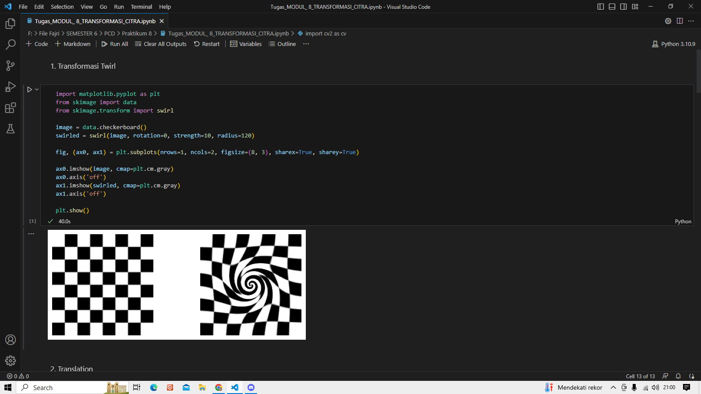

1. Translation

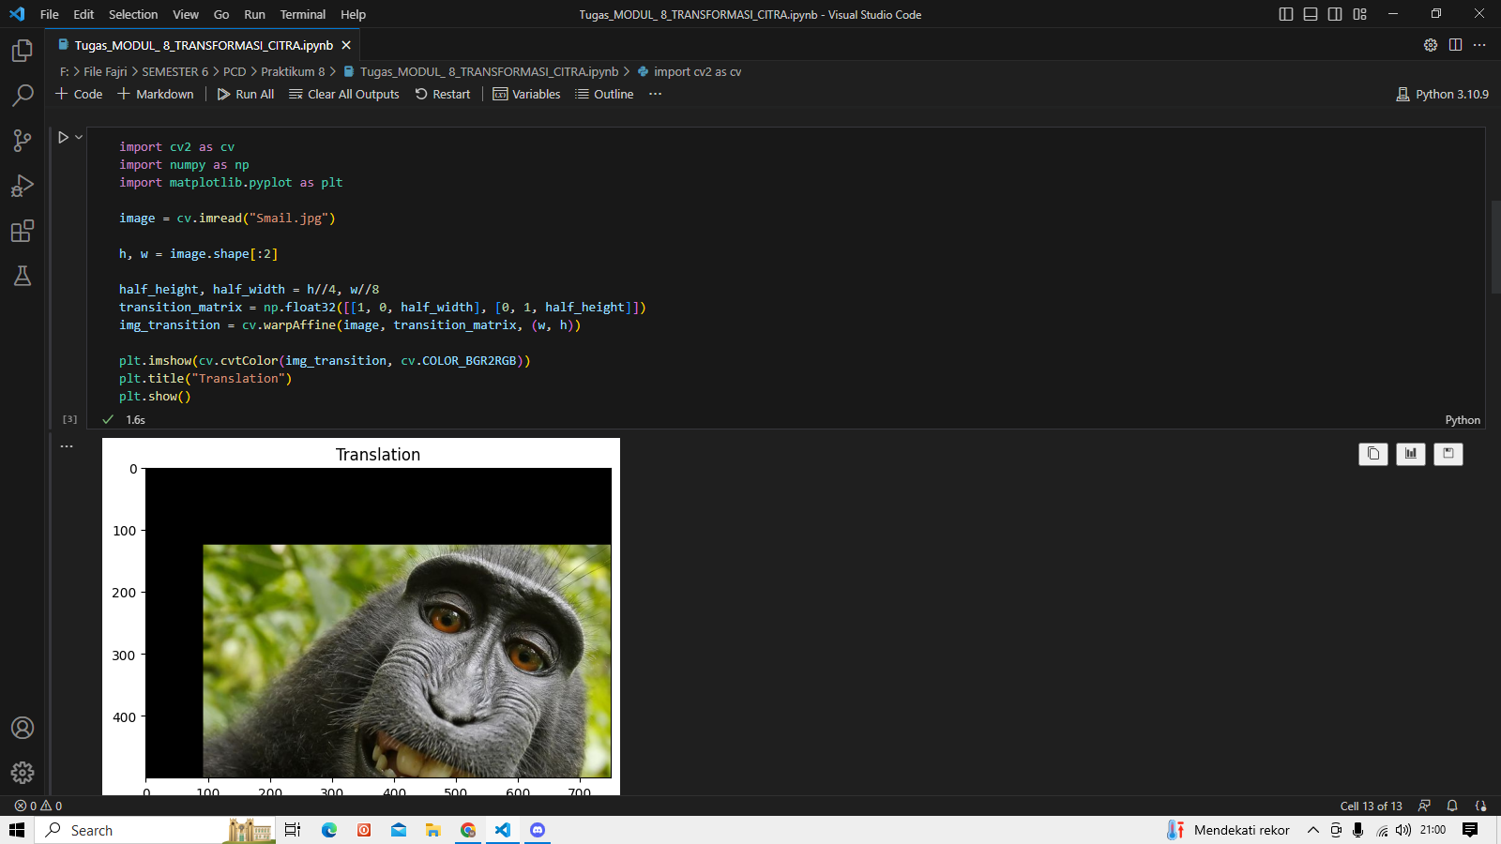

1. Rotation

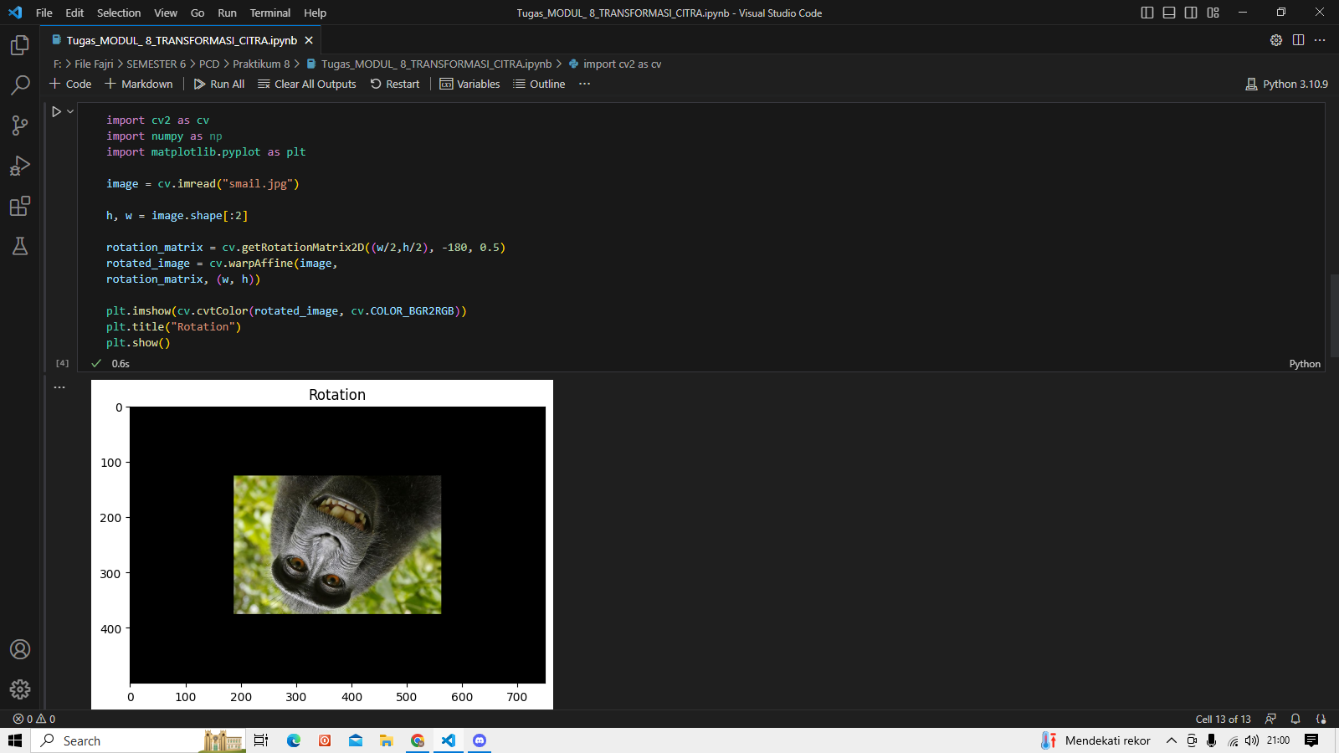

1. Interpolation

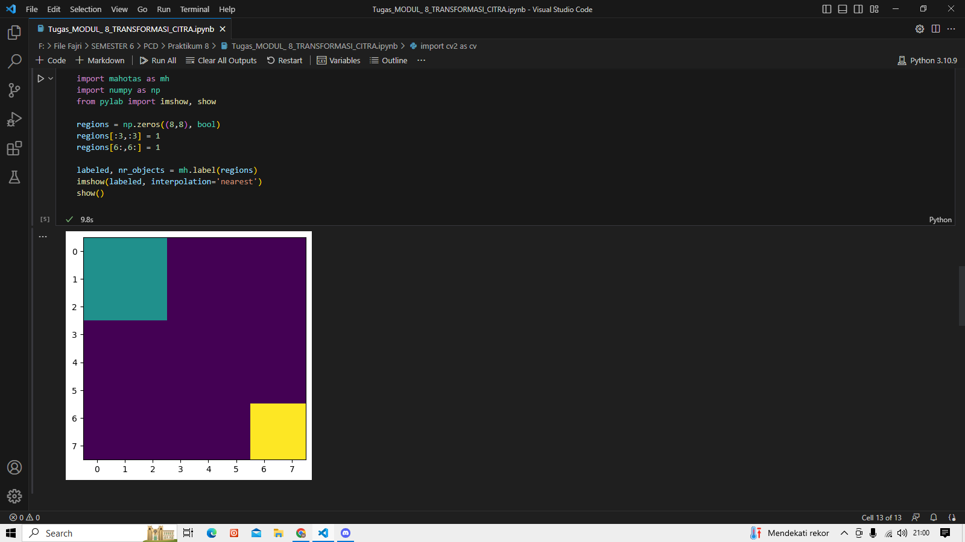

1. Skala Interpolasi Miring

